Date Datum: 15.04.2021
Location Ort: Singapore
Editor Autor: Jason Ang & Benjamin Burkhardt

Telescopic crawler crane in action – Presscrete Engineering employs 50 t SENNEBOGEN 653 E for Singapore’s massive underground Sewage superhighway

With their flexibility, strength, and easy operation, telescopic crawler cranes are delivering on their promise of getting the job done, especially in fast-paced and demanding job sites. They are the ideal machine for Pick & Carry applications. More and more companies are increasingly relying on telescopic crawler cranes to accomplish the lifting, moving, and positioning of heavy loads in confined construction sites.

Flexible, fast, efficient – the SENNEBOGEN 653 E telescopic crawler crane is designed to operate on difficult terrain thanks to its strong undercarriage traction. It can be easily transported and set up, ready to work in minutes even in tight spaces. Plus, the 653 E works quietly, which makes it ideal for construction projects in areas where noise levels are a concern.

The winning features of the 653 E telescopic crawler crane did not disappoint Presscrete Engineering Pte Ltd when the company decided to employ the high performance crane for the maintenance of Singapore's Deep Tunnel Sewerage System (DTSS).

DTSS is a massive integrated project being developed by the Public Utilities Board (PUB) to meet the island country's long-term clean water needs through the collection, treatment, reclamation, and disposal of used water from industries, homes, and businesses. Phase 1 of the project, which serves the eastern part of Singapore, was completed in 2008. Phase 2, which will connect Phase 1 to the southern and western part of the country, is ongoing and set to be completed by 2025.

Presscrete Engineering Pte Ltd has been providing specialist engineering services in Singapore and the region since 1987. Their services include Ground Engineering, Tunnelling and Civil & Special Engineering. With their expertise, Presscrete was entrusted to handle the maintenance of the DTSS Phase 1. Yearly maintenance is necessary to ensure the sewage highway runs smoothly.

The ideal telescopic crawler crane for demanding project sites
The more than 100 km DTTS system runs underneath major roads, which means maintaining it can be a real challenge. Maintenance requires the lifting and moving of people, material, and equipment throughout the DTTS conveyance system composed of link sewers, deep tunnels, and industrial tunnels. Narrow spaces, tight work schedules, noise level limitations, and multiple overlapping underground infrastructure are just some of the obstacles Presscrete Engineering has to overcome.

This is where the SENNEBOGEN 653 E telescopic crawler crane does its job - and does it well. Its lifting capacity of max 50 t coupled with two heavy duty hoisting winches that work side by side can safely handle tasks such as lowering man cages, mini excavators, and outfall pipes for maintenance work.

Moreover, SENNEBOGEN 653 E’s decoupled engine mounts and soundproofing enables it to operate quietly, keeping the sound pressure level in accordance with 2000/14/EC. Its strong, full-power boom, which can be telescoped from 9.4 m up to 30.4 m even under load, allows flexible use on any construction site. The telescopic crawler crane is easy to transport on a low-loader and is in principle ready to use immediately after unloading.

Another challenge lies in the skill and teamwork of the operator and signalman to maneuver around the multiple overlapping underground infrastructure such as underground power cable and water pipes. The electronic assist and build quality of SENNEBOGEN 653 E makes it very stable during lifting operation, which allows the operator to fully rely on the machine and focus his attention on the signalman and their surroundings.

To further enhance ease of operation, the cab has an unblocked panoramic view with a sliding door and wide door opening. Ergonomically designed consoles and joysticks, including push buttons and switches are all easily accessible on the optimized control panel.

Crane operator Mr. Cheong Hong Hwee is convinced: “The SENNEBOGEN 653 E so far is the sturdiest crawler crane I’ve ever operated. Which gave me the utmost confidence to do my lifting task.”

Caption:
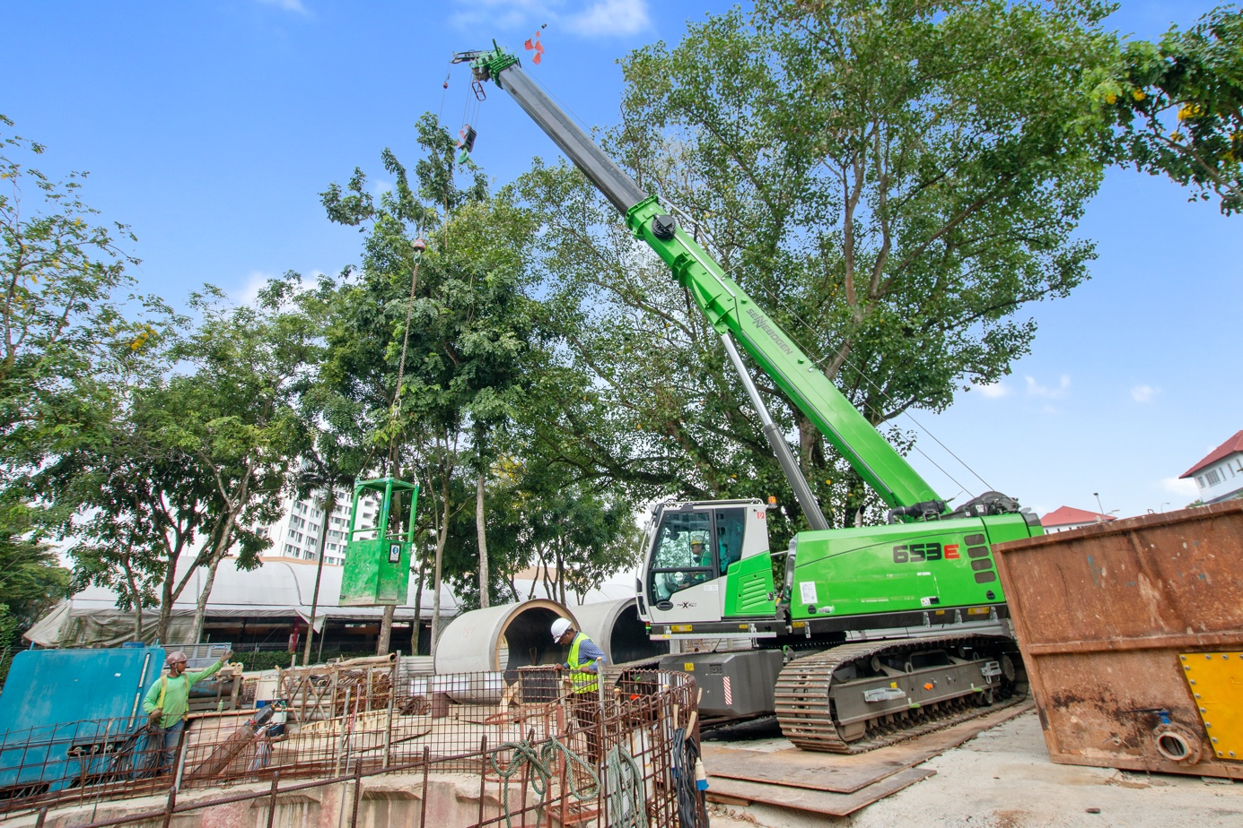

Perfect partner for tight spaces: Working right next to a main road with overlapping underground infrastructure the SENNEBOGEN 653 E supports the maintenance of the massive underground sewage highway in Singapore. At the narrow construction site the telescopic crawler crane is responsible for important handling tasks.

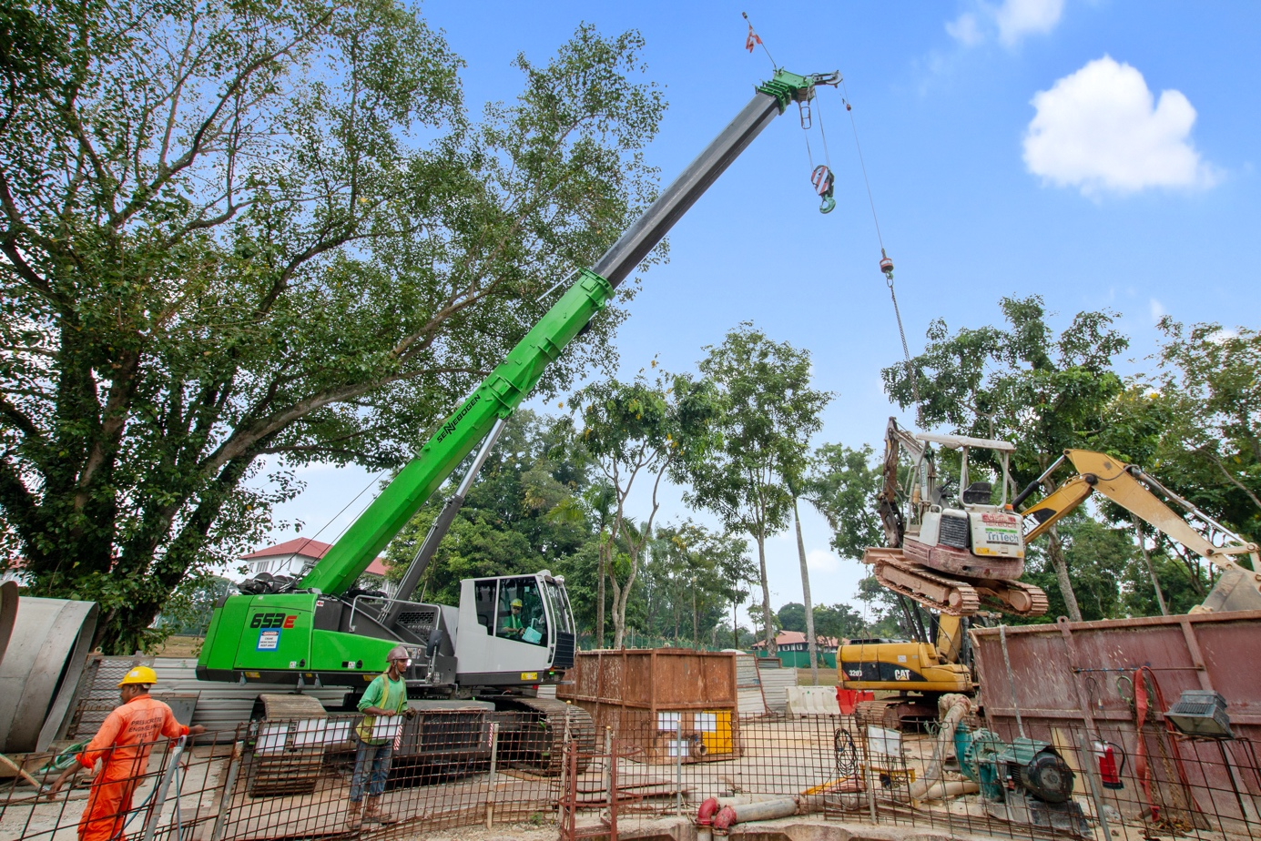

A maximum load capacity of 50 t and two heavy duty hoisting winches ensure that even heavy loads can be lifted safely and precisely.

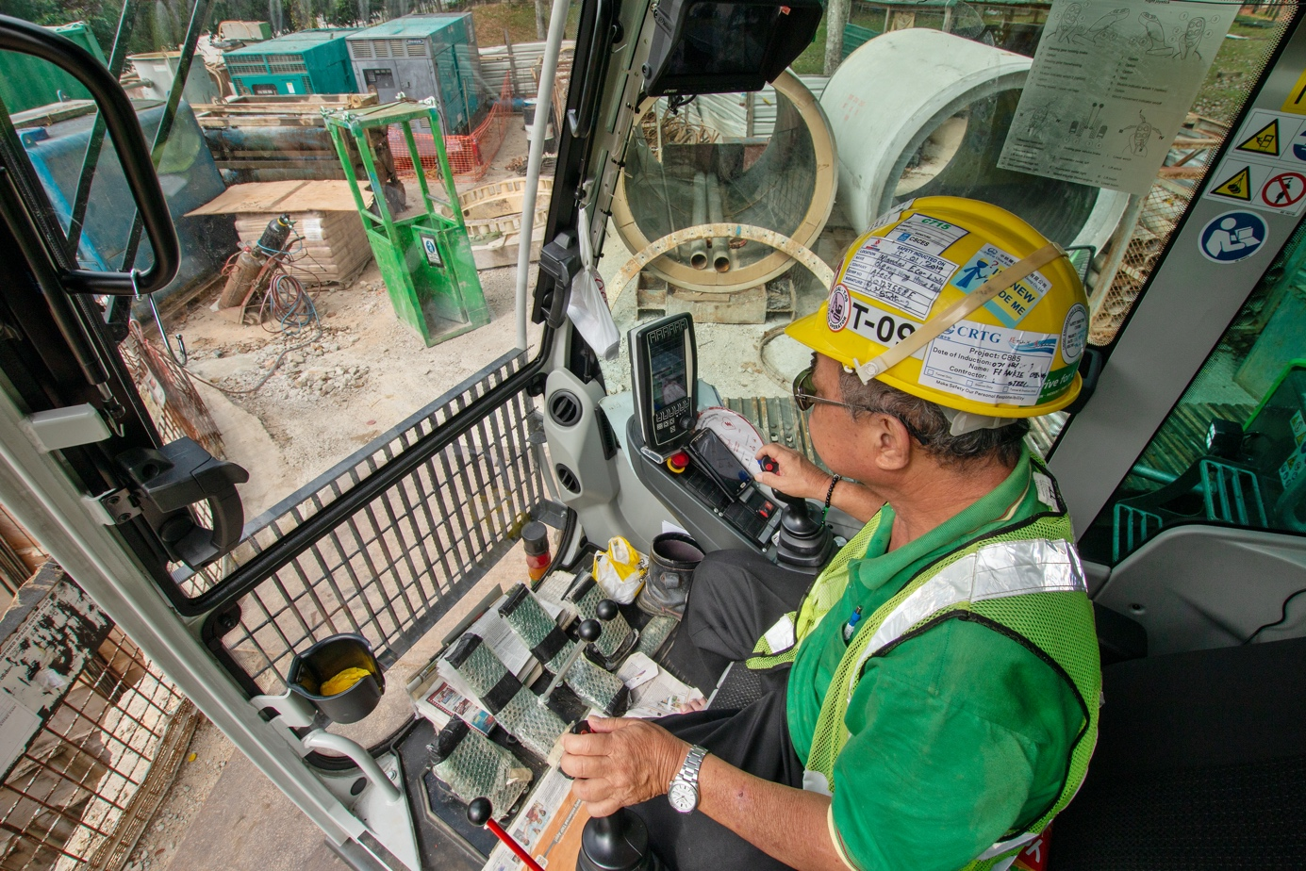

Maximum view – maximum safety: the SENNEBOGEN Maxcab offers machine operator Mr. Cheong Hong Hwee the best overview of his working area so that he can position the loads quickly, accurately and safely.

